Dung (Devlin) Hoang

DATA 5100

# Repot For Weather Project

While working on this project, I encountered a couple of coding and data structure issues. I was having a hard time cleaning up data and modifying the data frame, but I was able to overcome it by using information from [pandas.pydata.org](http://pandas.pydata.org). This was a helpful source for me to understand the code better, and I used it as a guide. Thus, my code and structure were optimized and tidied compared to the first attempt.

After the coding structure was resolved, the analysis was processed quickly. The average of precipitation was calculated and used to visualize the data. As shown below:

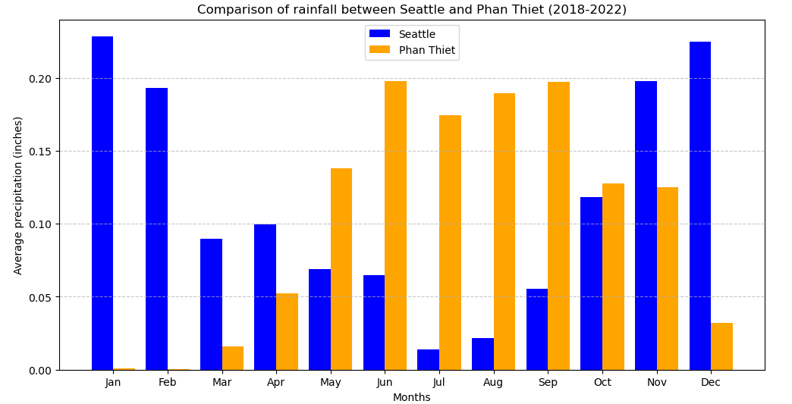

Figure 1: Bar graph comparing the average precipitation between two cities.

From this graph, Seattle shows a nice, evenly distributed precipitation throughout the year; in contrast, Phan Thiet only shows a concentration of rainfall during May through September. This could indicate how geography affects the amount of rainfall in each city. Phan Thiet is located in a tropical climate, which can be affected by the Monsoon season. This season is expected to bring more rainfall compared to other seasons. Seattle experiences a pleasant, evenly distributed climate due to its location near the ocean; during the winter months, warm air from the sea carries more rainfall toward the land. That is why we observed higher precipitation from November to February.

In conclusion, this analysis has highlighted the importance of weather and climate in influencing precipitation in various areas. It also demonstrates that visualization can be a helpful tool for gaining more in-depth data analysis.